**Chapter 6:**

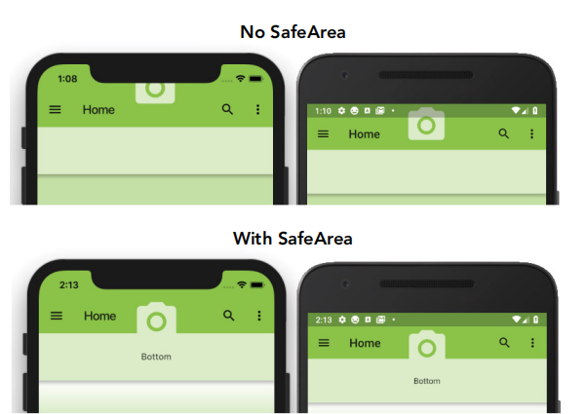Chapter 6 introduces the most commonly used widgets in Flutter, which are the foundational building blocks for creating visually appealing user interfaces (UI) and enhancing the overall user experience (UX). I’ve learned how to load images into my app, both from the application’s asset bundle and from the web using a Uniform Resource Locator (URL). This chapter also covers how to utilize Material Components icons and apply decorators to improve the appearance of widgets, or use them as input guides for entry fields. I’ve explored the Form widget and its role in validating multiple text field entries as a group. Additionally, I’ve learned how to detect the device’s orientation and adjust widget layouts accordingly, whether the device is in portrait or landscape mode.

